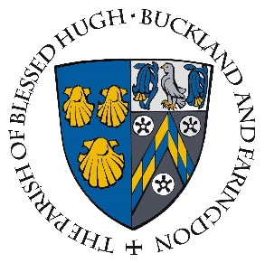

APPLICATION FOR BAPTISM*

About your child

Name
Sex | Male/Female
Age
Date of birth
Place of birth
Siblings’ names, ages

About you

At least one (1) parent, or person who lawfully has that role, must give their consent for the baptism. There must be a realistic hope that the child to be baptized will be brought up in in the Catholic religion.

Father’s name
Father’s religion | Catholic | Non-Catholic:
Mother’s name
Mother’s religion | Catholic | Non-Catholic:
Date of marriage
Place of marriage

About your Catholic faith

Assurances must be given that the gifts received in baptism (namely, freedom from original sin and a share in the divine life) can grow by an authentic education in the Catholic faith and life, in order to fulfil the true meaning of this sacrament.

Have you participated in baptism preparation in the last three (3) years?
Why have you decided to have your child baptized?
Do you attend Mass on Sundays?
Do you attend Mass on holy days of obligation?
(Holy Days of Obligation in the UK are: the feasts of the Epiphany (6 January), Ascension Thursday (40 days after Easter Sunday), Sts Peter and Paul (29 June), Assumption of the Blessed Virgin Mary (15 August), All Saints (1 November), and Christmas (25 December)
Do you receive the sacraments of reconciliation and holy communion at least once a year?
Do you pray together as a family?
Do you teach your children about God, his creation, Christ’s redeeming love for us, his commandments, the Catholic Church and the sacraments, and eternal life?
From time to time the Parish runs a short course for new and returning Catholics who want to know more about the faith. Would you like us to send you information about it?

About the child’s godparents

Godparents will be at least sixteen (16) years of age, and not be the father or mother of the child. At least one (1) godparent will also have received the Catholic sacraments of initiation, and be in good standing with the Catholic Church.

Godfather’s name
Godfather’s religion | Catholic | Non-Catholic:
Godmother’s name
Godmother’s religion | Catholic | Non-Catholic:

Contact details

The celebration of baptism is an occasion of great joy for our Catholic Parish. Once we have received your completed form and checked the details, you will be contacted to participate in baptism preparation and to set a date for the ceremony.

Best contact person
Relationship to child
Residential address
Telephone number
Email
Other comments

Would you like your child’s baptism celebrated during Sunday Mass?
Yes/No

Once fully completed, please return this form by email (cconde@portsmouthdiocese.org.uk) or in person to Fr. Claro at the church.

*Information provided on this form, together with all other personal data held about these individuals by the Parish and the Diocese of Portsmouth, is processed in accordance with the Diocese's Privacy Notice.

